How to make frontend automated (Continuous deployment)

Guide for the reference: <https://www.freecodecamp.org/news/how-to-set-up-continuous-deployment-in-your-home-project-the-easy-way-41b84a467eed/>

**!!!Note: For more sophisticated info use guide provided above, here will be provided only brief explanation on how to make Continuous Deployment.**

1. Upload your website including Dockerfile to GitHub or BitBucket.
2. In Docker Hub connect to GitHub or BitBucket
3. 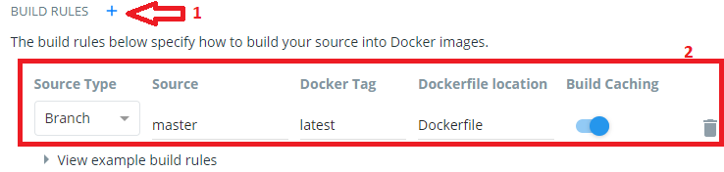Create repo in DockerHub from your GitHub or BitBucket repo. IMPORTANT: Make sure you add “latest” tag by pressing ‘+’ (1) while creating repo. It should look like the box below (2).
4. Create and build it.
5. Connect to the Frontend instance (Check User Manual – how to connect to the EC2 instance)
6. Install Docker (sudo apt install docker.io)
7. Run commands:

|  |
| --- |
| docker run -d --name watchtower -v /var/run/docker.sock:/var/run/docker.sock v2tec/watchtower |
| docker run -d -p 3000:3000 --name <my-project> <username>/<my-project> |

1. That’s all! Try accessing it on mikifrontend.x-raysoup.lol